NORTH HERTFORDSHIRE DISTRICT COUNCIL — AUGUST UPDATE

First Impressions as a new District Councillor
I have now attended sessions of each of the committees on which I sit: Southern Rural, Overview and Scrutiny, as well as the first meeting of the full council in this, its fortieth civic year. I have also undertaken various sessions of training and induction, from governance to IT.
The planning training was of great interest as it is very relevant for understanding the implications of the Local Plan, once available, and, although I am not a member of any of the committees at NHDC concerned with planning, I take a close interest in all applications which may affect Knebworth and continue to be a member of the Planning Committee on the Parish Council.
Knebworth Festival
Knebworth residents were not deterred by the wet weather over the final weekend of the festival. I enjoyed the finale concert performed by the Knebworth Community Chorus and friends at Knebworth House and the Fun Day was very popular as usual. Rosemary Conybeare, Vice-Chair of the Parish Council and I judged the Fancy Dress Competition and together with Stephen McPartland MP who opened the Fun Day, presented the cup to the winning entry from Years 2, 3 and 4.  A big thank you to Brian Worthington and his team for all the hard work. | 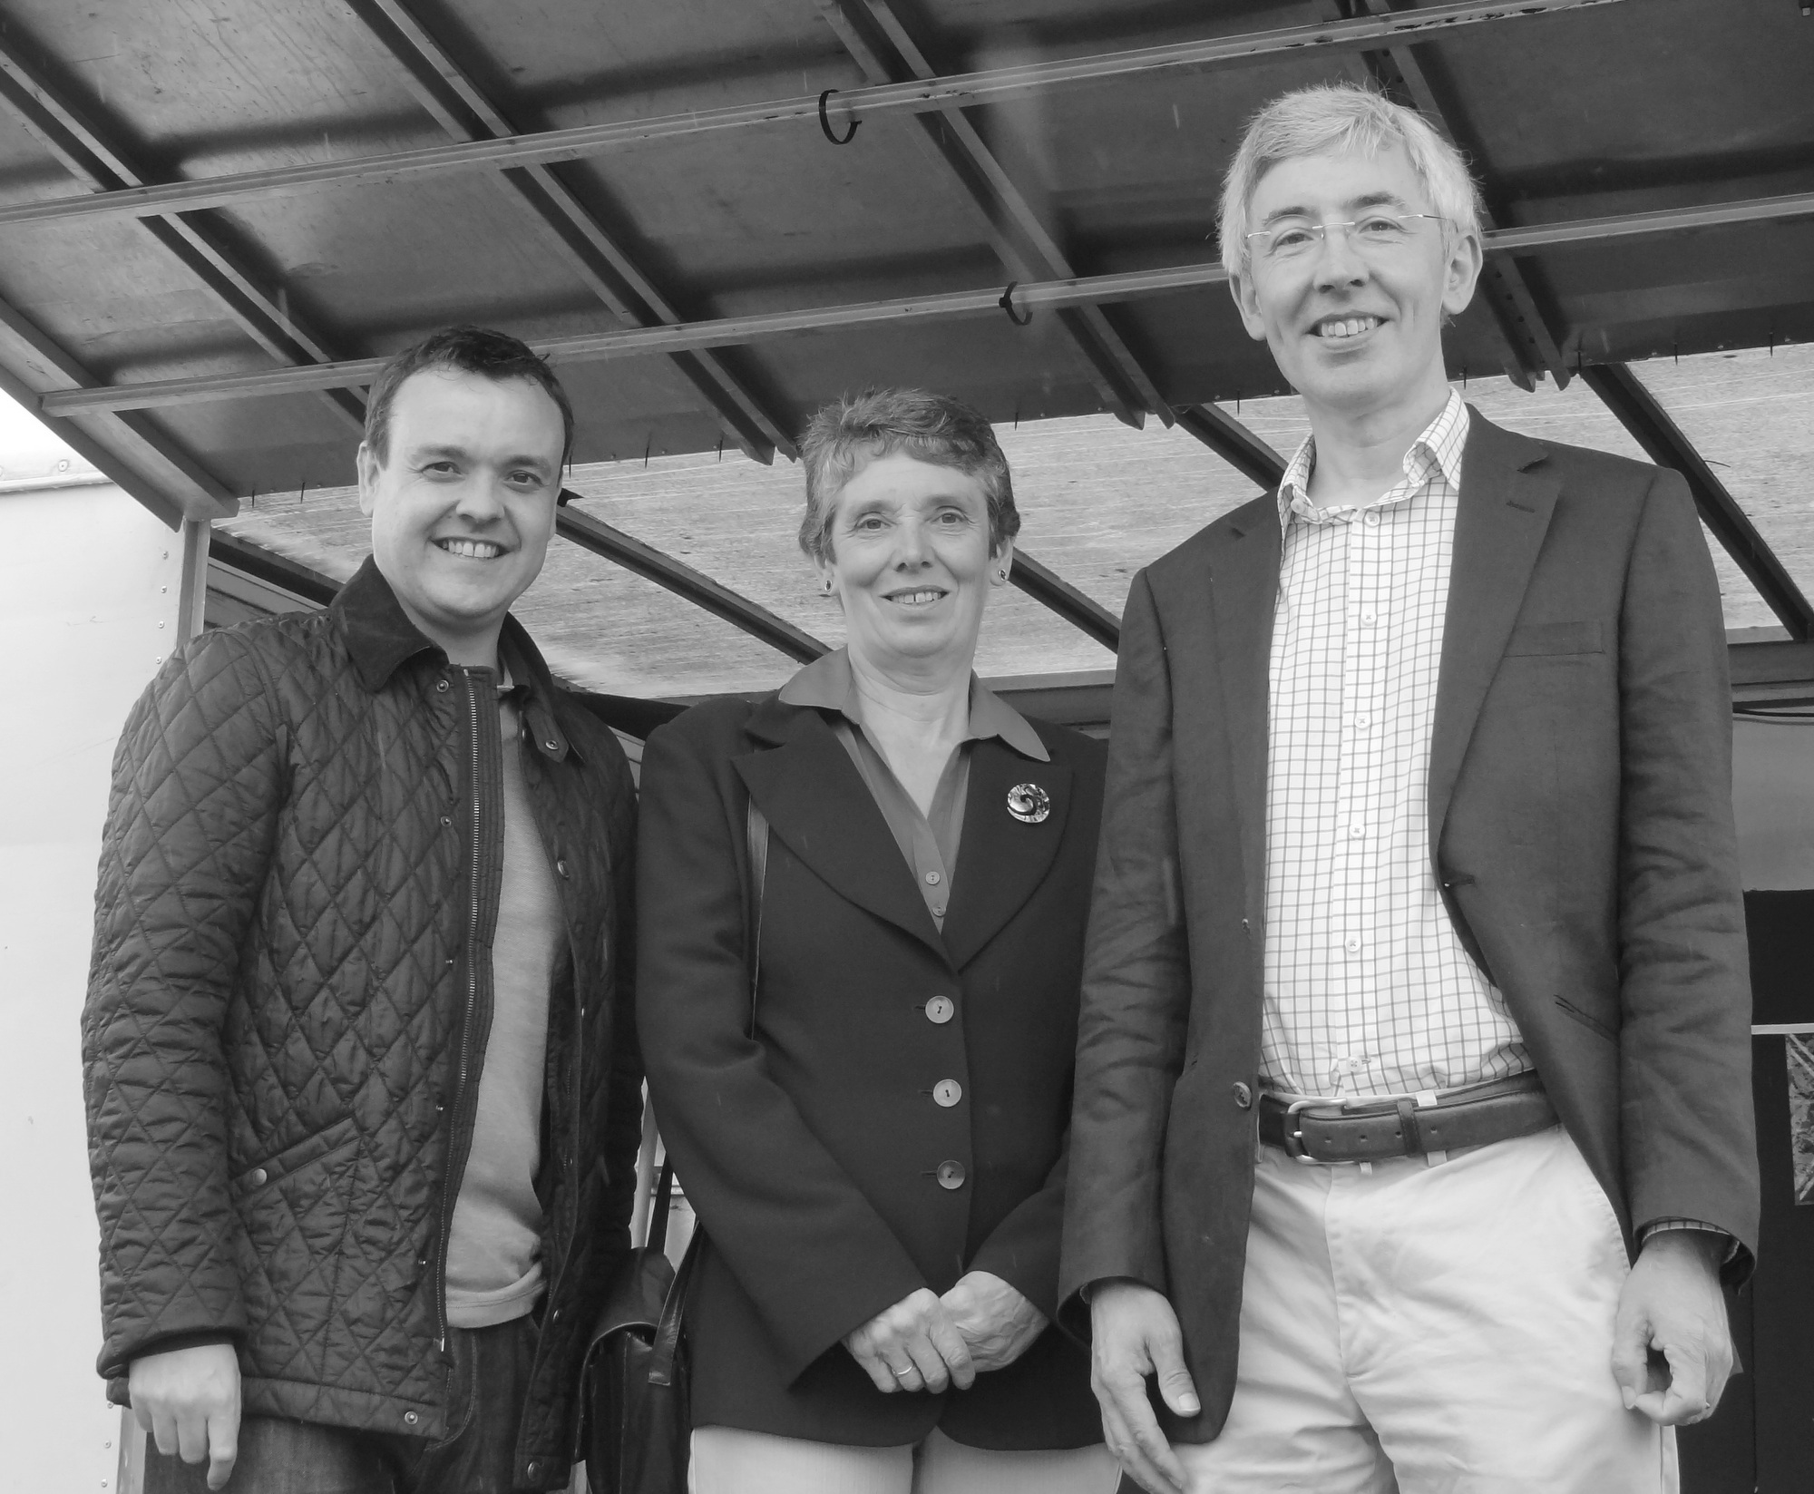
Pictured from left to right: Stephen McPartland MP, Cllr Rosemary Conybeare, Cllr Steve Hemingway
Solar Farm Application to North Herts District Council
An application is being considered to build a solar farm at Swangley’s Farm to the east of Knebworth. This would cover 50 acres and have a peak generating capacity of around 10 MW. There will undoubtedly be a great deal of discussion about this between now and when a decision would be made by the planning authority on whether to give approval.
Full details of the application are available on the NHDC Planning Portal on their website: www.north-herts.gov.uk.
Knebworth Village Trust
As a District Councillor in Knebworth I am, ex-officio, a trustee of Knebworth Village Trust. This charity supports community groups based with the parish of Knebworth. In our meeting in July we decided to support a youth group run by the Trinity Church and the (new amalgamated) Knebworth Football Club.
To find out whether your community group could benefit from a grant from the Trust, please contact the Hon. Secretary at info@knebworthtrust.com. The application form for grants is available on their website: www.knebworthtrust.com.

Please feel free to contact me about issues that affect you, or comments you wish to make.
Steve Hemingway, Councillor for Knebworth on NHDC: steve@stevehemingway.com BY PHONE on 01438 940594
Please contact Steve if you need his help or to share your comments, or be in touch directly with your County Councillor Richard Thake or your Member of Parliament Stephen McPartland:
- Richard Thake, Herts County Council: richard.thake@hertfordshire.gov.uk, 07973 157 605
- Stephen McPartland MP: stephen@stephenmcpartland.co.uk, Stephen McPartland MP, House of Commons, Westminster, London, SW1A 0AA

